CS 255 System Design Document Template

This template lays out all the different sections that you need to complete for Project Two. Each section has guidance to prompt your thinking. You will need to continually reference the interview transcript as you work to make sure that you are addressing your client’s needs. There is no required length for the final document. Instead the goal is to complete each section based on what your client’s needs are. Remove this note when you are finished, and replace all bracketed text with the relevant information.

UML Diagrams

UML Use Case Diagram
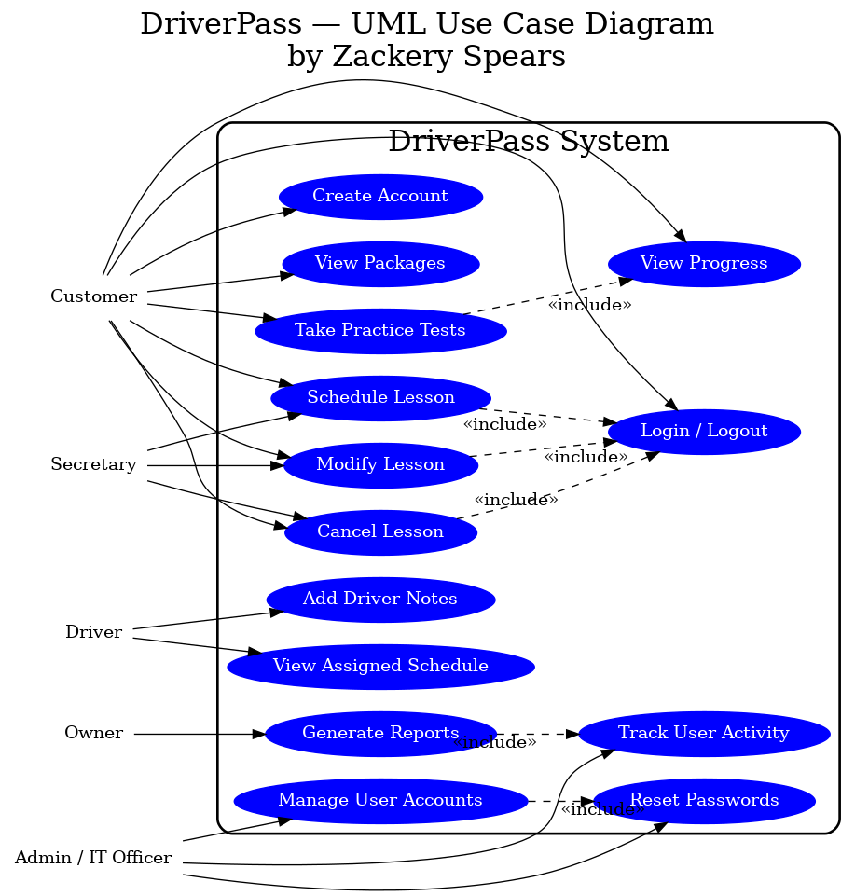

UML Activity Diagrams
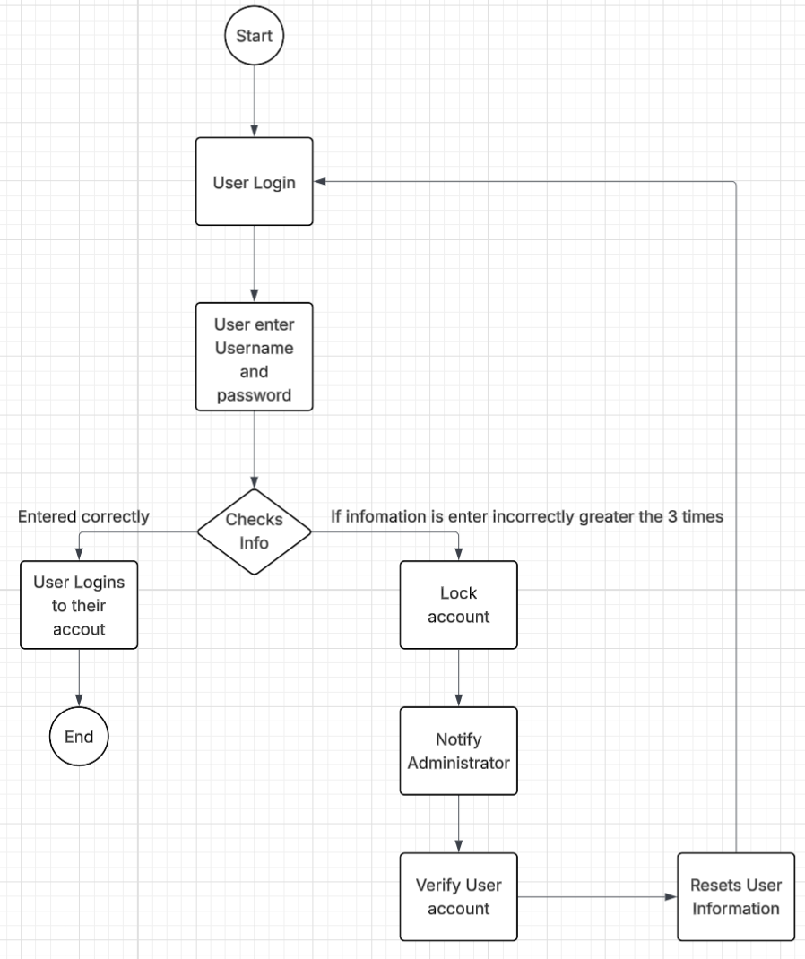

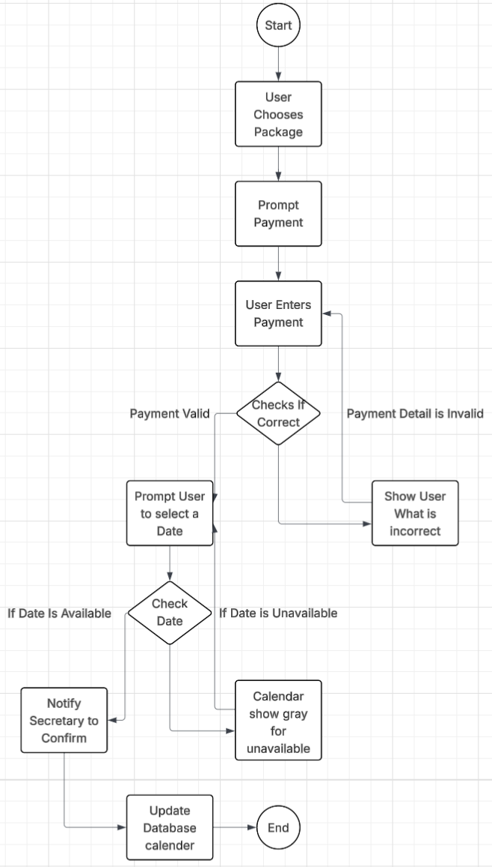

UML Sequence Diagram
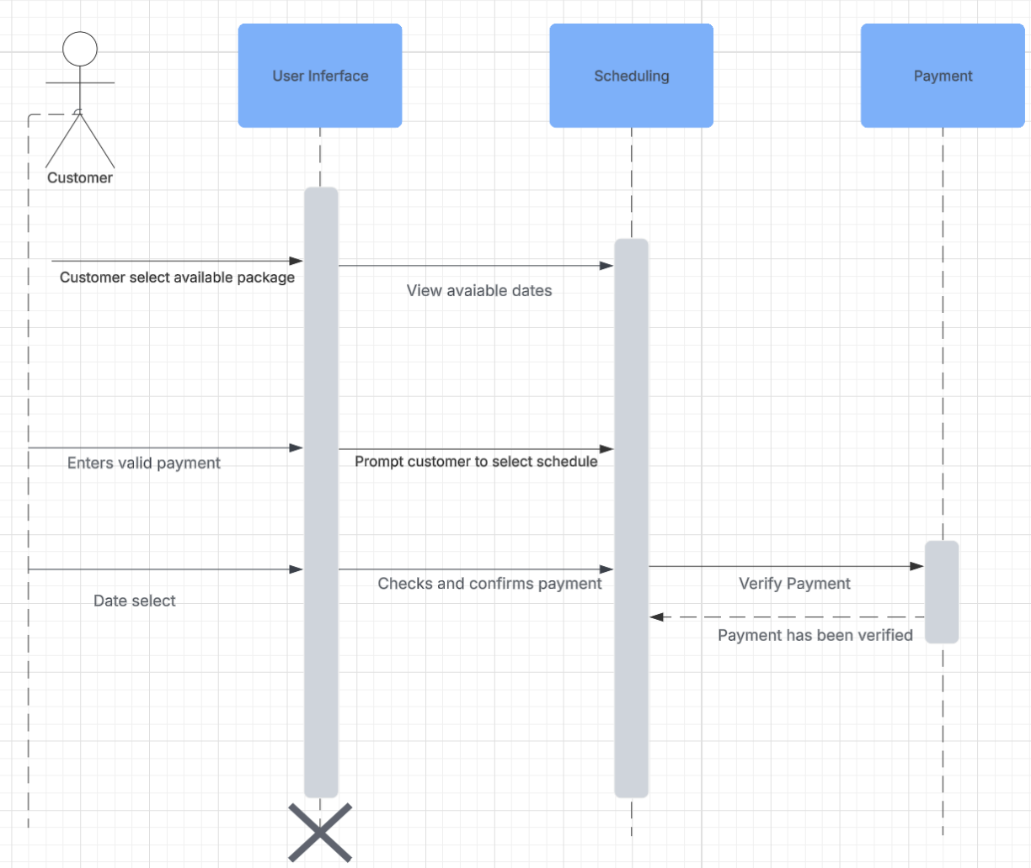

UML Class Diagram
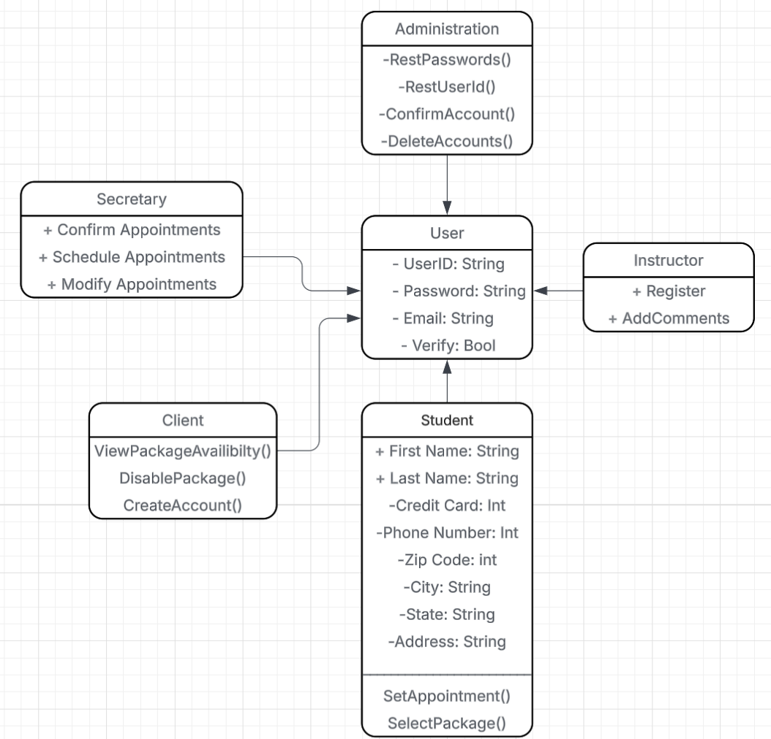

Technical Requirements
Database Server
- Relational database (e.g., MySQL, PostgreSQL, SQL Server) to store users, students, instructors, packages, appointments, payments, and audit logs.
- Role-based access control in the DB so only authorized processes/users can view or modify data.
- Regular automated backups and recovery procedures for all critical tables (accounts, schedules, payment history).

Application and Web Servers
- Dedicated web/application server to host the DriverPass site and business logic

Payment Processing Infrastructure
- Integration with a secure third-party payment gateway (e.g., Square, Shopify, Stripe) that supports credit/debit cards.
- Enforced HTTPS/TLS encryption for all payment and login traffic.
- Tokenization of card data so no raw card numbers are stored in the DriverPass database.

Authentication, Security, and Account Management
- Secure authentication service for username/password validation, including password hashing and password reset workflows.
- Account lockout mechanism after three failed login attempts and admin tools to verify and unlock accounts.
- Role-based authorization (Customer, Student, Instructor/Driver, Secretary, Admin/IT, Owner) controlling which screens and actions each role can access.
- Logging of user activity (logins, schedule changes, cancellations, admin actions) for audit and report generation.

Scheduling and Calendar Support
- Calendar/booking component integrated into the application to manage available dates and time slots.
- Logic and storage to mark dates as available/unavailable and to prevent double-booking.
- Notification system (email or SMS) to confirm appointments and send updates to students and staff.

